SQL Homework 02

Question 1

What authors are in California

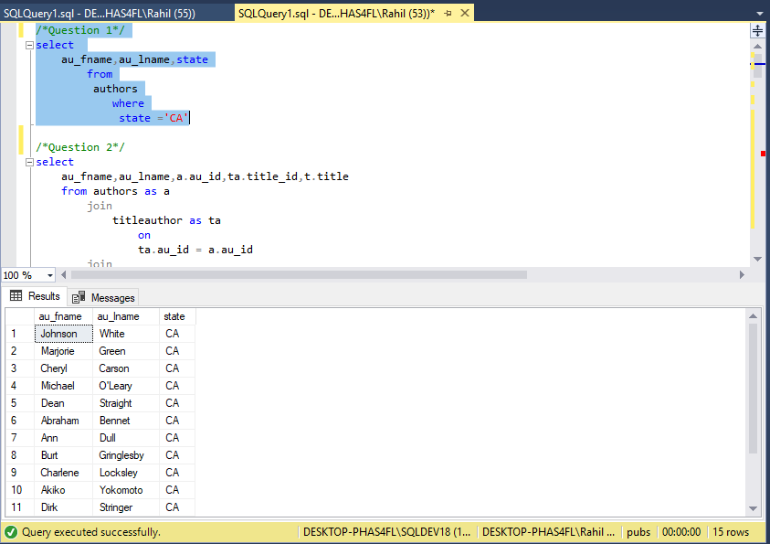

Question 2

List the titles and author names

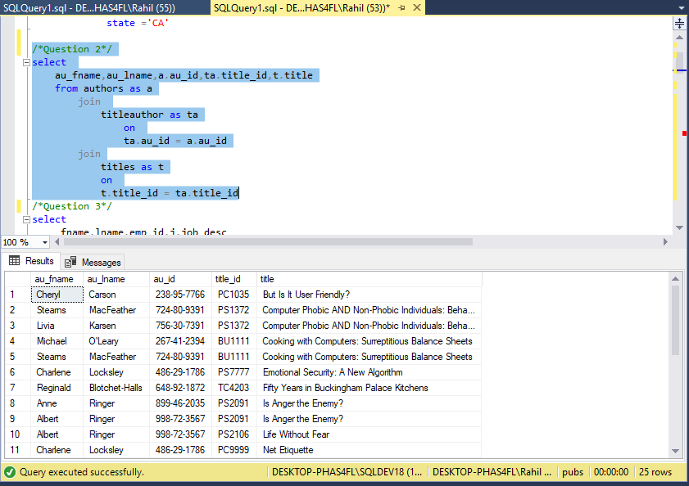

Question 3

List all employees and their jobs

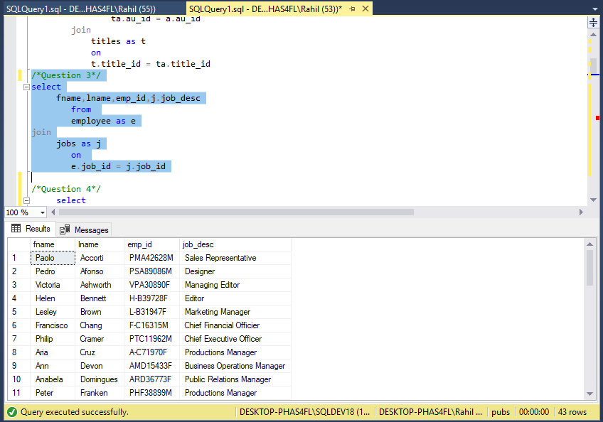

Question 4

List the titles by total sales price

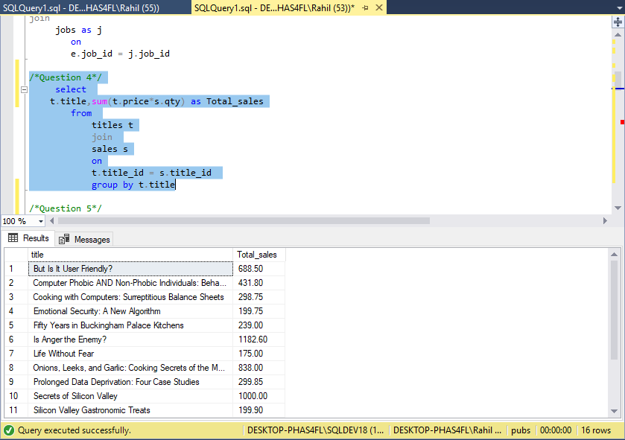

Question 5

Find the sales for stores in California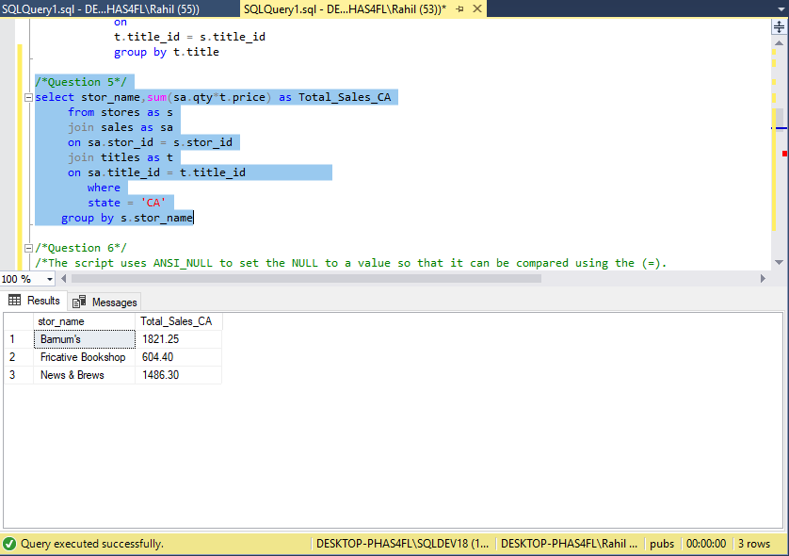

Question 6

Use SSMS to generate a script to create the authors table describe what the script does

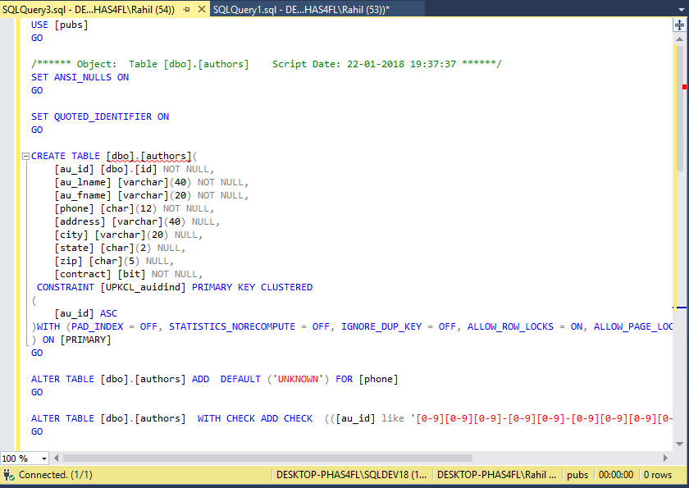

The script uses ANSI_NULL to set the NULL to a value so that it can be compared using the (=).

It then uses CREATE TABLE to create the authors table with the columns having specific name and their respective data types.

We use defaults and checks to add validations to the columns.

Question 7

Describe what the au_id is using for a data type?

The column au_id in authors uses the data type varchar(11) to create numerical and specials character (-) combination.

Question 8

List the store name, title title name and quantity for all stores that have net 30 payterms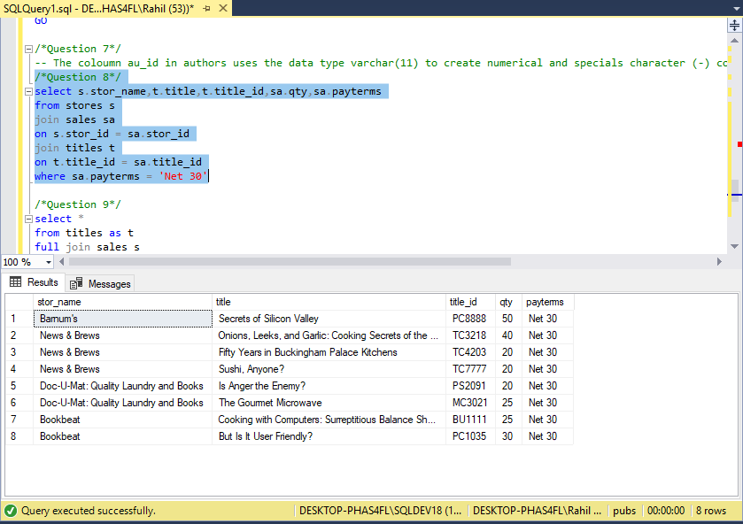

Question 9

Find the titles that do not have any sales show the name of the title

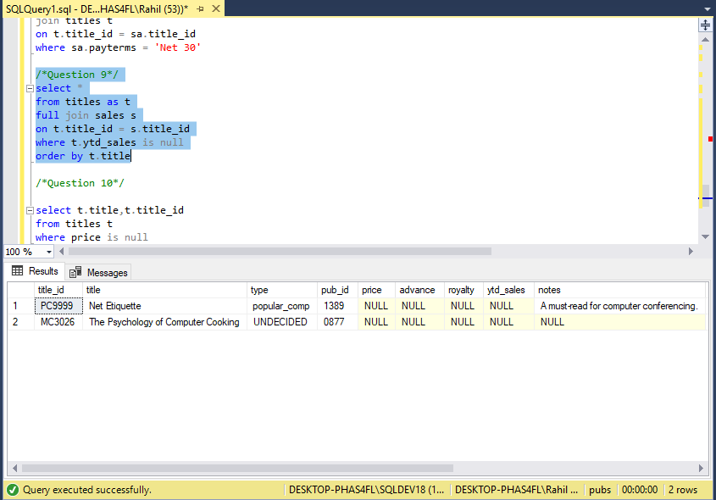

Question 10

Do previous question another way